State Change Manuscript Outline:
Introduction
- Global climate change is forecast to produce dramatic shifts in the frequency and magnitude of extreme climate events across ecosystems worldwide. Increased drought severity, wildfire intensity, and flooding are expected to significantly impact ecosystem structure and function.
- To better understand and adapt to these pressures, ecologists have increasingly focused on the concept of resilience – the ability of an ecosystem to resist change and self-reorganize following perturbation (Folke 2006).
- Resilience thinking has proven valuable when applied to systems that exhibit complex, nonlinear transitions between multiple states, and are increasingly used to guide management in a wide range of circumstances (Scheffer et al. 2001, Smith 2011, Angeler and Allen 2016).
- In particular, resilience thinking has provided a strong conceptual basis the management of arid and semi-arid rangelands, where traditional range models based on successional processes often fail to capture vegetation dynamics (Jackson and Bartolome 2002).
- Instead, range managers in these systems have turned to state and transition models (STMs), which describe plant community turnover as a set of transitions between discrete vegetation states. This approach attempts to recognize the complex interactions that govern vegetation composition by describing both the resilience of each individual state type and the many factors -- such as environmental variation and management actions – that guide transitions between them.
California Annual Grasslands
- California grasslands have long been a focal system in the study of nonequilibrium dynamics. Composed primarily of exotic annual species, these grasslands readily shift between dominant groups of taxa (George et al. 1992); High sensitivity to interannual climatic variation (Hobbs and Mooney 1995, Hobbs et al. 2007), non-hierarchical competitive dynamics (Uricchio et al. 2018), and strong priority effects (Young et al. 2014) combine to prevent grassland vegetation from long-term convergence to a single community type.

- Conceptually, California grassland vegetation are often partitioned into several distinct groups, including those based on functional type (grasses, forbs, and legumes) and provenance (native and exotic species). Distinctions are most frequently made between:
  - 1) Naturalized exotic annual grasses that now compose a majority of vegetation in California’s grassland ecosystems.
  - 2) Native perennial grasses and forbs thought to once cover much of the state’s grassland habitat
  - 3) A set of highly invasive annual grasses that are rapidly expanding throughout California rangelands.

- Past work has established general patterns in group life history strategy that correlate with colonization ability, invasion resistance, and response to climatic variation (Corbin et al. 2007, Harpole et al. 2007, Abraham et al. 2009).
  - Exotic and native grasses exhibit pronounced differences in seed physiology, growth habit, and fecundity. Large-seeded exotic annuals germinate rapidly with the onset of winter rains and invest heavily in reproduction before senescence, producing germinable seed densities up to 100,000 seeds/m² (Bartolome 1979).
  - Native grasses, on the other hand, often produce far fewer seeds of much lower mass that may fail to compete with annual grasses at early life stages. However, once established, hardy perennials are characterized by low mortality and long-term persistence without active disturbance (Seabloom et al. 2003).
  - Similarly to exotic annuals, invasive grasses produce seeds in high densities, though exhibit a later phenology and pronounced litter feedbacks that may inhibit growth of new colonists (Young 1992).
  - Through interaction with these different life history strategies, seasonal patterns of precipitation and temperature can exert considerable control over productivity and community composition in California grasslands (Pitt and Heady 1978, Reever Morghan et al. 2007). For example, periodic droughts early in the growing season are thought to result in significant mortality of annual grasses, while late-season rains may favor growth of invasive species.

- Recent, large-scale disturbances in the form of a historic drought and widespread wildfires have emphasized the need to predict vegetation dynamics as communities respond to these events. Current climate projections emphasize increased duration and intensity of drought events in California which may act as critical tipping points in many ecosystems (Shaw et al. 2009, Pierce et al. 2012, Prugh et al. 2018).
- As climatic variation is expected to increase in many systems globally, there is a clear need to provide analytical tools that can rapidly update core predictions as novel conditions present themselves.
Justification
- While primarily used as descriptive tools, state-and-transition frameworks employed by managers in California rangelands may also serve as a framework to analyze vegetation change in this system.
  - Given the highly dynamic nature of plant community assemblages, partitioning their total variance into a series of discrete states, rather than across a continuum of dissimilarity, may better capture fluctuations in vegetation type and assess critical questions related to community resilience.
- To date, attempts to incorporate STMs into statistical analysis have been limited. Empirical approaches have shown to be effective summarizing highly dynamic systems in certain contexts: Bagchi et al. (2012) and Stein et al. (2016) both used this method to explore cheatgrass spread and resistance in the American Great Basin, and transitions between exotic, native, and invasive plant communities in California rangelands.
- Central to this approach is the use of an algorithmic partitioning method to determine the composition discrete “states” and their frequency over time. The value of a state-transition model rests upon both the effectiveness of state types partitioning total variation in plant composition, and accurate prediction of transition events.
- As many ecosystems experience novel environmental conditions, this approach may be expected to be particularly valuable.
  - In most systems, taxa are considered to belong to belong to a series of discrete types, often related to ecological function, taxonomy, or provenance – such as distinctions between native perennial, naturalized annual, and invasive annual grasses in California rangelands. Under novel circumstances, previously observed group correlations in response may break down. Algorithmic partitioning of community variance may serve as a way to evaluate and re-define group memberships under formerly unobserved contexts.
  - A focus on discrete categorization of community states also provides an intuitive definition of resilience that closely resembles existing management tools. Resilience, in the context of a state and transition model, is simply the probability a state retains or returns to an assignment in subsequent observations. This modeling approach lends itself to practical application, providing a quantitative evaluation of the frequency and stability of state types in different environmental contexts.

.
- In light of recent climatic extremes influencing California annual grasslands, there is clear need to evaluate existing paradigms of vegetation dynamics used to guide ecosystem management.
  - While many controlled experiments have explored the effects climatic variation on plant productivity and competition, few have attempted to evaluate how environmental variation controls long-term patterns of turnover among dominant species.
  - Quantitative STMs offer an opportunity to evaluate drivers of vegetation change and provide insights into mechanisms of species coexistence in non-equilibrium systems.
- Here, we assess interactions between community assembly and climatic variation on vegetation composition in California annual grasslands across a 10-year period encompassing recent drought (2013-2016) and potential recovery. Using data from experimental plantings of three key grassland species groups – naturalized annual, native, and invasive species – we aim to test key assumptions of the resilience of different communities and the potential drivers of transition between them.
  - What “states” best partition observed variance in plant community composition? What species define these states?
  - What states arise with different planting composition mixtures? As these states are observed over time, are transitions between states characterized by continuous, reversible changes or non-reversible changes?
  - How do key drivers of community composition (assembly order and climate) govern transitions between states?

Materials and Methods:
Study site
- Field plantings were conducted in research fields at the University of California, Davis (38.545751, -121.784780). Previously used in crop production, these fields were left fallow from 1985 to the start of experimental plantings in 2007. 75% of field is composed of Reiff series soil (coarse-loamy, mixed, superactive, nonacid, thermic Mollic Xerofluvents); other soil present (< 25% of the area) is the Brentwood soil series (fine, smectitic, thermic Typic Haploxerepts) with a 0-2% slope (USDA Web Soil Survey, http://websoilsurvey.sc.egov.usda.gov).
- In the early fall of 2017, soil was disked, irrigated, and received a broad-spectrum herbicide (glyphosate) prior to planting to remove the existing seed bank.
- Three planting mixtures were established based on common delineations between vegetation types in California anna grasslands (Table 1). For all possible 1-, 2-, and 3-group planting combinations, we established eight 1.5m x 1.5m plots (2.25 m²; 56 plots total).
- In each 1.5 x 1.5 m plot, a total of 139 grams of seed was added. This seeding rate reflects an average of 8,000 plants/m2, a typical mature plant density in this system (Heady 1958). For each monotypic community (e.g. natives vs. invasives. Vs. naturalized), an equal proportion of seeds of each species was added. For community mixtures, an equal proportion of community type seed was added (e.g. in invasive + naturalized, 50% invasive, 50% naturalized seed), with equal proportion of individual species within each community type.
- In each growing season from 2008 – 2018, total areal cover of all species was estimated visually to the nearest 10%. Cover observations for each species were performed in mid-and late-spring to capture the season of maximum percent cover for each species, because any one sampling wouldn't account for variation in species phenology.
Delineation of States
- Due to intermittent invasions by agricultural weeds, community analyses were performed on a subset of the total community corresponding to species that were planted in our initial mixes, in addition to Bromus diandrus, a common naturalized annual grass that was self-recruited into the experiment during the drought. The resulting dataset captured 93% of the total vegetation abundance observed over the course of the experiment.
- To assign state types to each observation, we partitioned total community variation into a series of potential states using an unsupervised clustering algorithm, K-medioids clustering.
- K-medoids clustering randomly selects k of n total datapoints as group “medoids” and computes the sum of distances between points and their associated medioid, based on Bray-Curtis dissimilarity. This algorithm then iteratively swaps these mediods and recalculates summed distance to achieve a solution that best captures the total variance of the data
- To determine the most appropriate number of states, we applied k-medioids clustering across values of k from 2-10. We then subjected the output of each of these runs to a battery of tests—Hartigan, CH, Beale, KL, Cindex, DB, Silhouette, and Duda indices (Charrad et al. 2014). The value of k with the most consist performance across all tests was used to determine the number of clusters that best represented discrete partitions within this dataset.
- Following the partition of states, we then conducted indicator species analysis to establish what species are associated with each state.
Weather data
- Weather data was provided by a local California Irrigation Management Information System (CIMIS) monitoring station in Davis, CA (38.535694, -121.777636). CIMIS automated dataloggers collect weather data on a minute-by-minute basis, including air temperature, soil temperature, precipitation, solar radiation, vapor pressure, and wind speed. We aggregated these data into monthly intervals, where we calculated Standardized Precipitation-Evapotranspiration Index (SPEI), a metric of drought stress (D) at a given timepoint, i:
- Where P_{i} represents observed precipitation and ETo_{i} represents estimated evapotransporation. ETo was calculated using the Penman-Monteith equation, defined as:
- Where R_{n} is net radiation, G is soil heat flux, (e_{s} – e_{a}) is the vapor pressure deficit of air, ρ_{i} is the mean air density at constant pressure, c_{p} is the specific heat of air, Δ is the slope of the saturation vapor pressure temperature relationship, γ is the psychometric constant, and r_{s} and r_{a} are the surface and aerodynamic resistances (FAO).
- SPEI offers flexible, variable timescale estimations of drought stress that can be used to quantify the effects of multi-year climate patterns (Vicente-Serrano et al. 2010).
- To provide context for climate patterns observed during our study, we calculated SPEI for a 35-year span between 2018 and 1983, the first year sufficient climate data was collected. To account for temporally lagged effects of climate variation (Dudney et al. 2017, Prugh et al. 2018), we created drought indices across several cumulative water year durations. For each year, we calculated SPEI for a single water year (October – May; 8 months), two consecutive water years (20 months), and three consecutive water years (32 months). We then standardized these values by fitting the drought index series to a log-logistic distribution, wherein scaled drought indices represent historic droughts (-2) to historic wet periods (+2).

SPEI Figure
- 1st panel shows mean annual precipitation in mm, with average from 1983 – 2018 as a dashed line
- 2nd panel shows the value of the SPEI index over the course of our study, standardized relative to climate patterns from 1983 – 2018.
- 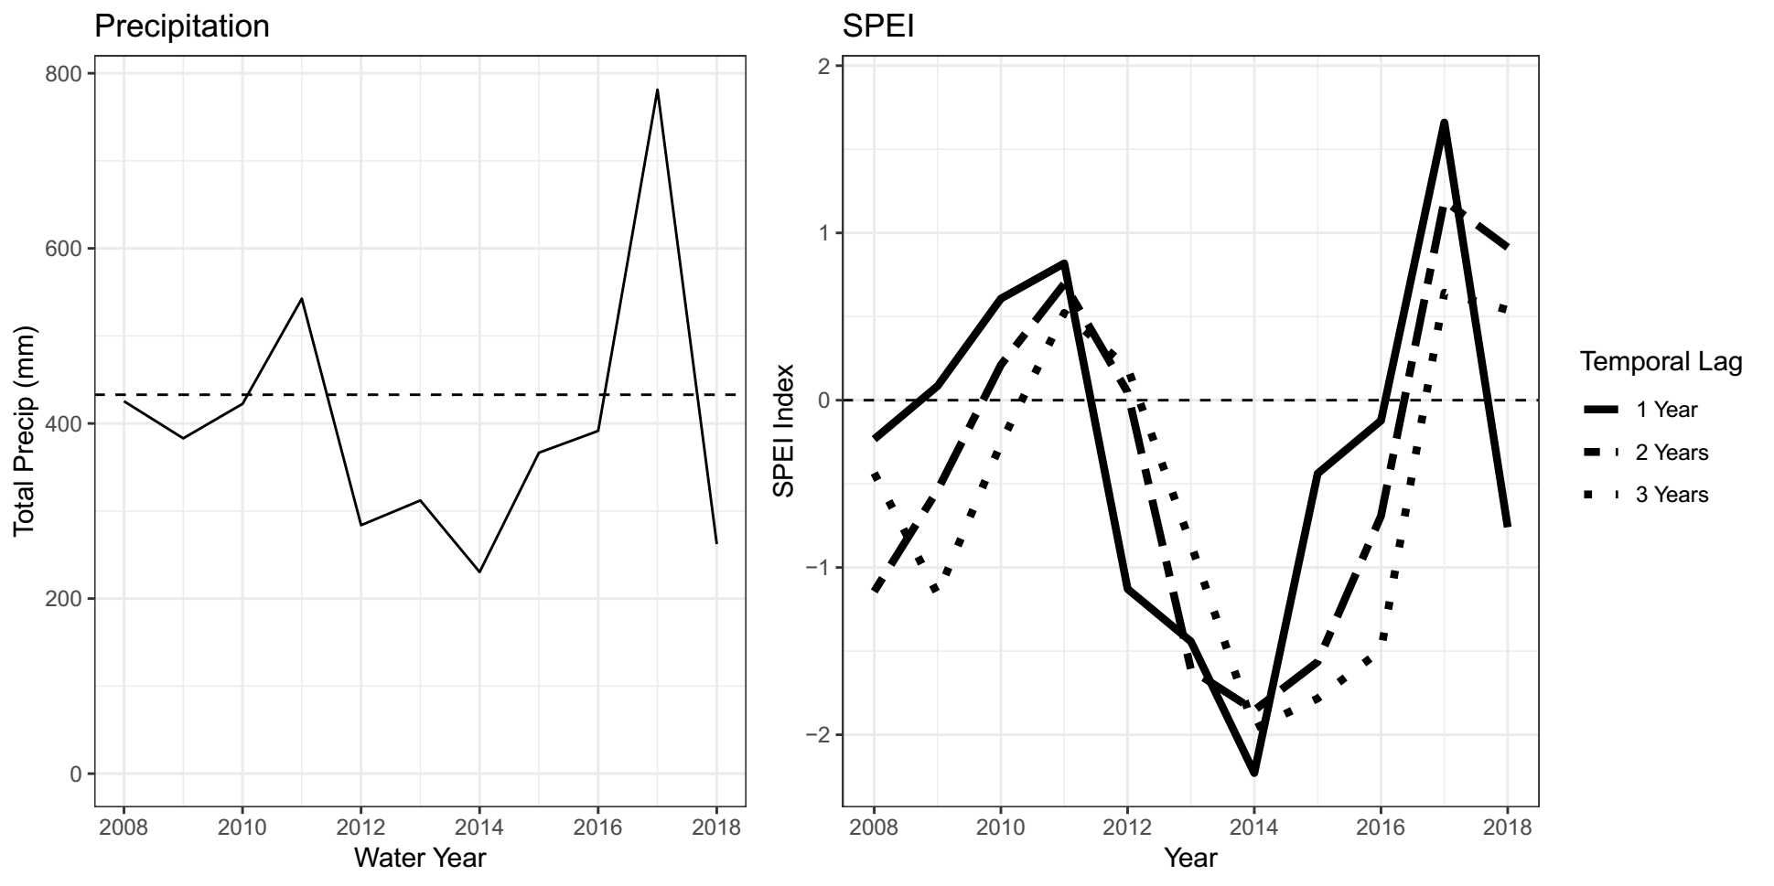

- All SPEI calculations were performed using the package “spei”.
Construction of State-Transition Models
- Following the association of observations to discrete states, we fit a multistate model (Markov model) to the data. Multistate models represent systems where subjects transition between a set of discrete classes over time and may be uniquely suited to examining state and transition models through a statistical framework.
Modelling transition probabilities
- Following we constructed a multistate model consisting of all states identified in clustering analysis, with probabilities fit to all possible transitions between states.
- To test for effects of initial planting composition and climatic variation on the probability of state transition, we added a series of covariates to multistate models that correspond to SPEI and the presence of state indicator species in the initial planting composition.
  - E.g, the probability that a community in state 1 will transition to state 2 in the next year of observation can be represented by:
‘
  - Where q₁₂ is the baseline probability of a transition, and β₁ and β₂ are coefficients fit to recorded SPEI values and planting composition, respectively.
- After fitting models with and without SPEI and initial planting covariates for 1-, 2-, and 3-year drought indices, we then calculated AIC scores for each model. We selected the model with the lowest AIC score (ΔAIC < -2) as our best fit model. Further comparisons between subset models containing nested sets of parameters were made using likelihood ratio tests.
- Multistate model fitting and model selection was performed using the “msm” package.
R packages:
- Data were visualized using “ggplot2” and “network”.
- SPEI calculations were performed using the package “SPEI”. Clustering and diagnostics were generated using the packages “pam” and “nbclust”.
- Indicator species analysis was performed using “vegan”.
- Construction of multi-state models was conducted with the package “msm”
- All analyses were conducted in R version 3.06.
Results
- Cluster assignments
- K-medoids clustering of community observations (56 plots x 10 years, n = 560) and assessment of cluster fit indicated that community variation was best partitioned using k = 4 unique cluster assignments (Appendix 1).

- NMDS of state assignments
- Visualization of cluster assignments and associated species correlations was conducted through non-metric multidimensional scaling (NMDS).
  - Figure shows total variation in community composition for all observations between 2008 and 2018, in addition to clustering assignments. Shape and color of points indicate results of K-medoids clustering.
- Species vectors highlighted are those with significant (P < .05) cluster associations as calculated through indicator species analysis (Figure 3).
- There appears to be considerable similarities among certain groups of species vectors, in addition to some novel ones.
  - Some associations are predicted based on seed mix types and conceptual understanding of the system, such as A. triuncialis and E. caput-medusae, B. carinatus and E. glaucus; others less so, such as A. fatua and A. americanus.
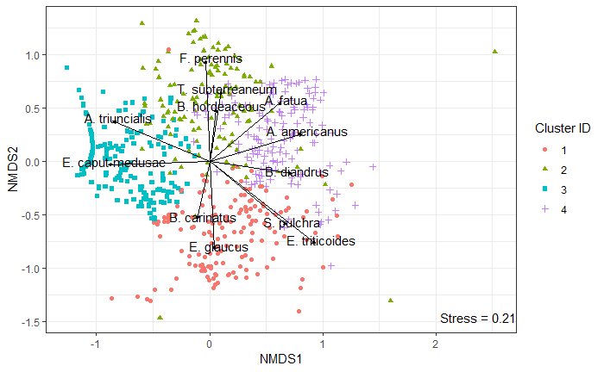

- Indicator species analysis table
  - Indicator species analysis of cluster assignment revealed several species-cluster associations, three of which appear to follow the general patterns of species provenance – Native species (cluster 1), naturalized annuals (cluster 2), and invasive species (cluster 3). However, the fourth cluster assignment is significantly correlated with a mixture of both naturalized and native species.
  - Average percent cover of two strongest indicator species in each group is presented in Appendix 3.

- Cluster Assignment Frequency over Time plot
- Tracking individual plot assignments over time demonstrates clear differences in state assignment based on seeding composition and non-random transition probabilities over time.
- Initial assignments:
  - Consistent with observed colonization ability of California vegetation types (annual, native, invasive), initial state assignments produced a clear pattern in species relative abundances following seeding.
  - All plots receiving a seed mixture containing naturalized species (mixtures 2, 4, 6, and 7) received the same assignment, characterized by annual grasses F. perennis, B. hordeaceous, and annual legume T. subterreaneum.
  - Plots which received a seed mixture including invasive species in the absence of naturalized exotics (mixtures 1, 3) received the same cluster assignment, characterized by invasive grasses E. caput-medusae and A. triuncialis.
  - Native dominated state assignments, on the other hand, were only present in seeding mixes that solely contained native species (mixture 5).
  - For plot-level detail in state assignments, see appendix 4.
- Transitions:
  - Communities demonstrated little stability in state assignment over the course of observation, though plots appeared to differ substantially in their transition direction and frequency based on seeding mixture and experiment duration.
  - In particular, the frequency of communities given a state 2 assignment (F. perennis – B. hordeaceous) dropped precipitously following the first year, often transitioning to an invasive dominated assignment in the 2nd through 5th years of the study, or a fourth assignment (A. fatua – B. diandrus) that became more common in the 7th and 8th years of observation. Given the presence of a moderate wet period (2009 - 2011) and a historic drought (2012 - 2016), changes in assignment frequency imply a relationship between community performance and environmental conditions.
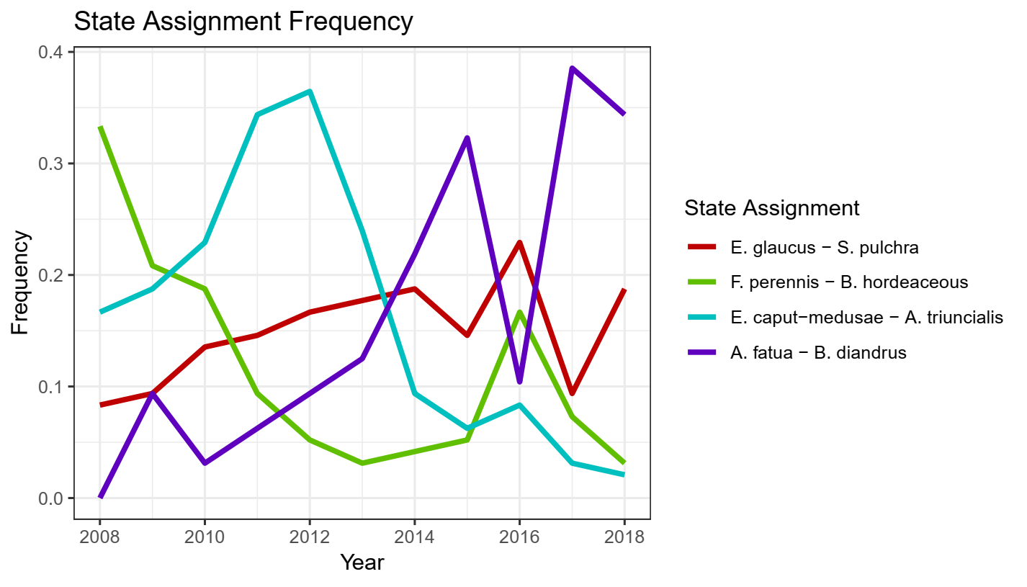

- Transition frequency table
- The following table shows the total number of transitions observed over the 10 years of sampling encompassed in this dataset (n = 554). Entries along the matrix diagonal represent communities which retained their previously identified state in a following year’s observation, while off-diagonal entries represent communities which have experienced a transition.
- Interestingly, transitions appear to be frequent and widely distributed in this dataset. All possible transitions occurred, but some appear more common than others – natives (cluster 1) appear to have rarely transitioned to cluster 2 or 3, for example.
  - Most transitioning happens from cluster 4 (with similar shift to all 3 other clusters)

- Transition Probability Diagram
Directed graph demonstrating average probability of an observation retaining its state assignment in the following year (values within circles) or transitioning to another state assignment (labelled arrows) across all observations from 2007 – 2018. State diameter and arrow width are scaled by the probability of stability, or transition, respectively.

This figure suggests that there is little evidence for convergence of plant communities to a single community type over the course of our observation, consistent with notions of non-equilibrium in this system. Three community types (E. glaucus – S. pulchra, E. caput-medusae – A. triuncialis, and A. fatua – B. diandrus) all exhibit relatively similar stability, while the fourth, F. perennis – B. hordeacous, was quicker to change its state assignment.

However, the magnitude of transition probabilities differed significantly based on the direction of change. Some states, such as 2 and 4, appeared to “flip-flop” frequently between one another, while other pairs of states, such as 2 and 3, showed unidirectional patterns of change.

- AIC model selection table
- To better understand drivers of change between state assignments, multi-state modeling was used to quantify the influence of two hypothesized covariates – initial seeding composition and climatic variation.

- The model selection table below shows comparison between models fit using no covariates, models incorporating the influence of planting composition (whether a given state assignment was represented in the species mix used in planting), and climatic variation (SPEI).
- This table shows that the best fit model in this case (lowest AIC score) is one that contains covariates related to planting composition and 1 year drought. The 3 year drought model is also an acceptable alternative, and the 2 year drought model isn’t a whole lot worse than the other two.
- Chi-squared goodness of fit test of the best fit model showed no significant deviations from model assumptions ($χ_{9}^{2}$ = 12, p > 0.20)

State Resilience
- Given the observed influence of climatic variation and planting composition on transition probabilities in multi-state modeling, subsequent inference about these parameters may shed insights into how state types are responding to these drivers.
- This figure below focuses on stability -- the probability that an observed community retains its composition in subsequent sampling, relative to drought stress (SPEI) and contingency.
- Modelled responses indicate that:
  - Over the course of our experiment, species composition in planting reduced stability in state assignment, suggesting that arrival order may influence vegetation transitions over time. These effects may be the result of priority effects, in which established vegetation is able to pre-empt resources or alter the local environment; or barriers to seed arrival and recruitment.
  - The stability of two states, in particular, appeared strongly affected by drought. State 3: “E. caput-medusae – A. triuncialis”, composed of invasive annual grasses, and State 4: “A. fatua – B. diandrus”, composed primarily of naturalized exotic species, exhibited differing responses to SPEI. Invasive grasses increased in stability as conditions grew more wet, while this group of annual exotic species appeared to prefer drought conditions, suggesting key differences in the climatic adaptation of these species groups.

Exploration of individual transition probabilities between state pairs provides further evidence for the influence of covariates on variation in vegetation composition.
- Transition to native states strongly affected by seeding composition
- The following figures show the probabilities of transitioning to states 1, 3, and 4.
  - Panels A, B:
    - The probability of transitioning to a native dominated state was greatly increased when native species were represented in initial seeding mixes – this effect implies strong barriers to establishment in this species mixture.
    - Drought stress also affected modeled transition frequency, though this effect was most detectable when native species were already represented in the seeding mixture. Transition from state 3 to state 1 strongly increased with drought stress, while transition from state 4 to state 1 decreased with water availability.

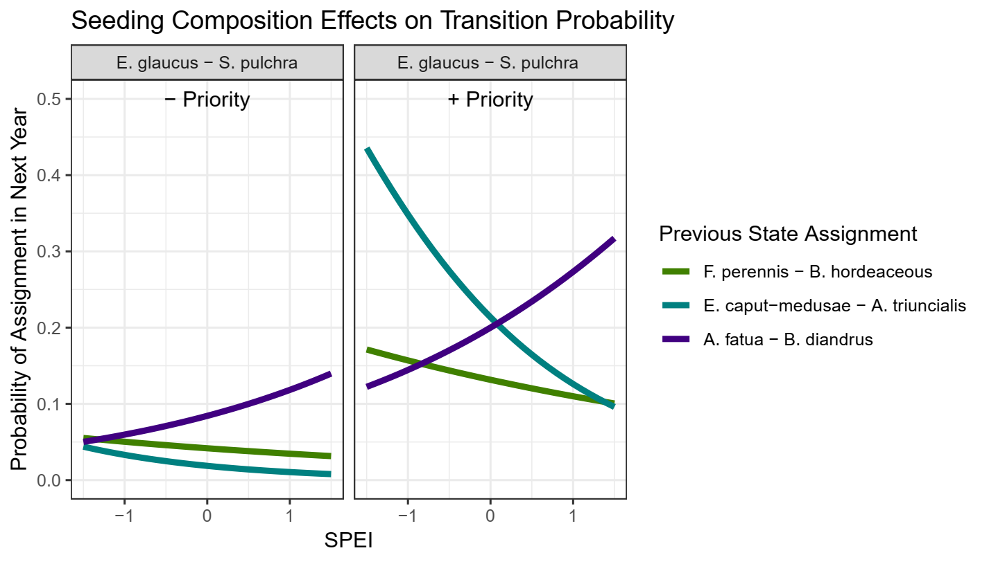

- Transition to naturalized annual and invasive species states depends on climatic variation
The following figure shows the probability to transition to either State 4: A. fatua – B. diandrus or State 3: E. caput-medusae – A. triuncialis (Panel 1 and 2, respectively). Colored lines indicate which state a community is transitioning from, while panel labels show what state assignment is given in the following year.
In particular, this figure demonstrates the strong influence of climate on the probability of transitioning to these two states, one which appears to increase in abundance when conditions are significantly drier than average, another that increases when conditions are significantly wetter than average.
These changes in transition frequencies demonstrate variation in the environmental adaptations of these species groups; consistent with our expectations, later phenology invasive grasses (E. caput-medusae – A triuncialis) are rapidly able to invade plots of exotic annual grasses when precipitation is high. On the other hand, all states increased in their transition frequency to a state dominated by two annual exotic grasses, A. fatua and B. diandrus, when precipitation fell far below historic norms.

Discussion
Key points to address:
- Classic assignments of different group types do still tend to operate well, but miss out on some nuances that are better captured by quantitative STMs
- A mixture of drought and priority effects seem to govern turnover in plant community composition and coexistence over time
  - Native species, in particular, are stable, but seem unable to establish when not given an initial boost
  - Groups of exotic species partition climate space
- Increasing variance in climatic variation, in the long term, may amplify fluctuations in community composition over time.

- Given the study’s context within a historic drought, it is important to consider that this range of community variation we see may not be representative of the full scope.
Revisiting previous questions:
- What states best partition observed variance in plant community composition? What species define these states?
  - 3 of 4 state assignments roughly follow the general notion of divisions between native, exotic, and invasive annual grasses. However, a fourth distinct state appears to have emerged post the onset of a historic drought in 2012-2015. While other clusters are characterized by species that follow rough notions of pre-existing associations within the system, this new assemblage arising during the drought period is identified by both naturalized and native grasses that appear able to capitalize on the unique conditions produced by this event.
    - This finding illustrates the power of partitioning methods to identify discrete vegetation types that may arise under novel circumstances in a given system. Conceptual notions of species “groups” which exhibit correlated fluctuations in abundance often form the basis for exploratory analysis and management action. While keen observers may be able to identify key vegetation types over the long-term, more sensitive quantitative approaches are better predisposed to capture these correlations when deviating from historical norms.
    - However, we encourage caution in the interpretation of these approaches, which may be biased by the scale and duration of sampling; our study, characterized by a historic drought, is not likely to represent the full scope of environmental variation experienced within this system, and should serve to complement, not replace, traditional state-transition frameworks.
- Are transitions between states characterized by continuous, reversible changes or non-reversible changes?
  - As may be expected in a system characterized by non-equilibrium dynamics, transitions between vegetation clusters occurred frequently during the duration of sampling without clear convergence to a single community type.
  - However, transition frequencies were not uniform across all groups, instead varying as a function of priority effects, environmental variation, and state assignment. In particular, these trends appear to broadly reflect established patterns of colonization ability, invasion resistance, and environmental affinity in constituent species.
    - Exotic annual grasses which dominate State 2, for example, were able to quickly dominate communities when represented in seeding mixes. Despite initial colonization, State 2 assignments were characterized by low stability and quickly transitioned, often to cluster 3 (invasive species).
    - This is in contrast two State 1, native perennial grasses, which were characterized by high stability across a variety of climatic conditions, but largely unable to compose a significant proportion of communities where they were not represented in initial seeding.

  - We find that many transitions between communities are reversible and highly frequent, corresponding with our notion of these communities as being dominated by non-equilibrium dynamics.
  - However, over the course of our experiment, we also found that certain states varied considerably in their resilience and transition direction. Native states appeared to be resilient to largely resilient state change, while others, such as State 2 composed of a subset of annual grasses, dominated many planting compositions early on, but were not particularly stable.
- How do key drivers of community composition (assembly order and climate) govern transitions between states?
  - Consistent with reported invasions of exotic annual grasses, transitions between annual dominated states and invasive species are frequent, particularly in wet years.
  - However, severe drought appears to have dramatic effects on both the stability and persistence of different states. States dominated by invasive species, which exhibit later phenology, were likely to shift to a more drought-tolerant state when during the historic drought from 2014 – 2016.
  - Assembly order continued to have large effects on patterns of community turnover, years after planting.
    - This effect was most pronounced in “native” states – even when native species were not dominant early on, planting compositions that contained native species were more likely to transition to a native state later on. Conversely, communities that did not receive any native seed very rarely experienced a state transition, despite close proximity to seed sources of native grasses.
      - Important for restoration; native species may appear when conditions are favorable, even if not abundant early on. Consistent with notions of spatial storage effects in perennial grasslands.
- Broader conclusions
  - State and transition modeling reveals the influence of key properties influencing vegetation turnover in non-equilibrium systems – resilience as an emergent property of state types, environmental variation, and priority effects.
    - The considerable variation in responses to drought among state types may act as an important stabilizing mechanism in California annual grasslands, contributing to the diversity seen in this system despite a long history of exotic invasion.
    - Competition – colonization tradeoffs are also hinted at by differences in state representation immediately following seeding and state resilience. Certain annual grass taxa, which formed the basis of state assignment 2 that represented a vast majority of plots in our first year of sampling, may thrive in contexts where seed arrival, rather than competition, structures plant communities. Native perennial grasses that formed State 1 are thought to be strong competitors once established, but appear limited in their recruitment.
      - Finding further confirmed by studies examining perennial grass establishment through seed addition (e.g. Seabloom et al. 2003).

- Some important caveats
  - State-transition approaches are great at distilling down temporal community dynamics into groups of species that have similar patterns of abundance, but may not yield particularly nuanced insights.
    - While interpretation of state-transition models can be informed by other studies of individual species dynamics, it’s difficult to determine within-state differences in species abundance in state change models. In our case, this may be an inability to determine whether species are responding to drought, or immediately afterword.
  - This sort of analysis is limited to the scope of total community variation observed within a given time series of observations – quantitative analysis can be used to complement and test predictions made by expert models, not necessarily to create new models from scratch.
    - Detection of environmental parameter effects depends on variation observed (what will happen with drought recovery, for example?)
    - Limited to the species pool present in a given site. If state-transition models are meant to describe the phases and states that may appear within a given soil type or management context, these all need to be present to be tested in a quantitative fashion.

References (Incomplete)
Allen-Diaz, B., & Bartolome, J. W. (1998). Sagebrush – Grass Vegetation Dynamics : Comparing Classical and State-Transition Models. Ecological Applications, 8(3), 795–804.
Bagchi, S., Briske, D. D., Wu, X. B., McClaran, M. P., Bestelmeyer, B. T., & Fernández-Giménez, M. E. (2012). Empirical assessment of state-and-transition models with a long-term vegetation record from the Sonoran Desert. Ecological Applications, 22(2), 400–411. https://doi.org/10.1890/11-0704.1
Briske, D. D., Fuhlendorf, S. D., & Smeins, F. E. (2005). Society for Range Management State-and-Transition Models , Thresholds , and Rangeland Health : A Synthesis of Ecological Concepts and Perspectives Author ( s ): D . D . Briske , S . D . Fuhlendorf and F . E . Smeins Published by : Society for Range Manage. Rangeland Ecology & Management, 58(1), 1–10. https://doi.org/10.2111/1551-5028(2005)58<1
Briske, D. D., Bestelmeyer, B. T., Stringham, T. K., & Shaver, P. L. (2008). Recommendations for development of resilience-based state-and-transition models. Rangeland Ecology and Management, 61(4), 359–367. https://doi.org/10.2111/07-051.1
Briske, D. D., Fuhlendorf, S. D., & Smeins, F. E. (2003). Vegetation dynamics on rangelands: A critique of the current paradigms. Journal of Applied Ecology, 40(4), 601–614. https://doi.org/10.1046/j.1365-2664.2003.00837.x
Clary, J. (2008). Rainfall seasonality determines annual/perennial grass balance in vegetation of Mediterranean Iberian. Plant Ecology, 195(1), 13–20. https://doi.org/10.1007/s11258-007-9294-9
Corbin, J. D., & D’Antonio, C. M. (2010). Not novel, just better: Competition between native and non-native plants in California grasslands that share species traits. Plant Ecology, 209(1), 71–81. https://doi.org/10.1007/s11258-010-9722-0
Crawford, J. A., Olson, R. A., West, N. E., Mosley, J. C., Michael, A., Whitson, T. D., … Boyd, C. S. (2018). Society for Range Management Ecology and Management of Sage-Grouse and Sage-Grouse Habitat Published by : Society for Range Management Stable URL : http://www.jstor.org/stable/4003949 Linked references are available on JSTOR for this article : Synthesis P, 57(1), 2–19.
Elmendorf, S. C., & Harrison, S. P. (2009). Temporal variability and nestedness in California grassland species composition. Ecology, 90(6), 1492–1497. https://doi.org/10.1890/08-1677.1
Everard, K., Seabloom, E. W., Harpole, W. S., & de Mazancourt, C. (2010). Plant Water Use Affects Competition for Nitrogen: Why Drought Favors Invasive Species in California. The American Naturalist, 175(1), 85–97. https://doi.org/10.1086/648557
Gea-Izquierdo, G., Gennet, S., & Bartolome, J. W. (2007). Assessing plant-nutrient relationships in highly invaded Californian grasslands using non-normal probability distributions. Applied Vegetation Science, 10(3), 343–350. https://doi.org/10.1111/j.1654-109X.2007.tb00433.x
Harpole, W. S., Potts, D. L., & Suding, K. N. (2007). Ecosystem responses to water and nitrogen amendment in a California grassland. Global Change Biology, 13(11), 2341–2348. https://doi.org/10.1111/j.1365-2486.2007.01447.x
Henneman, C., Seavy, N. E., & Gardali, T. (2014). Restoring Native Perennial Grasses by Changing Grazing Practices in Central Coastal California. Ecological Restoration, 32(4), 352–354. https://doi.org/10.3368/er.32.4.352
Jackson, R. D., & Bartolome, J. W. (2002). A state-transition approach to understanding nonequilibrium plant community dynamics in Californian grasslands. Plant Ecology, 162(1), 49–65. https://doi.org/10.1023/A:1020363603900
Prugh, L. R., Deguines, N., Grinath, J. B., Suding, K. N., Bean, W. T., Stafford, R., & Brashares, J. S. (2018). Ecological winners and losers of extreme drought in California. Nature Climate Change, 8(9), 819–824. https://doi.org/10.1038/s41558-018-0255-1
Seabloom, E. W., Harpole, W. S., Reichman, O. J., & Tilman, D. (2003). Invasion, competitive dominance, and resource use by exotic and native California grassland species. Proceedings of the National Academy of Sciences of the United States of America, 100(23), 13384–9. https://doi.org/10.1073/pnas.1835728100
Stein, C., Harpole, W. S., & Suding, K. N. (2016). Transitions and invasion along a grazing gradient in experimental California grasslands. Ecology, 97(9), 2319–2330. https://doi.org/10.1002/ecy.1478

Appendices
- NBClust k selection test output

- Visualization of the relative percent cover of all species by state assignment
- Older figure, need to think of a better way to convey this information, if needed.

- Mean cover across all plots of 2 most representative species per cluster
An important caveat here when interpreting this graph – correlated responses in general do not demonstrate the same rationale that is used to generate clusters. While these are related, an aggregated visualization like this does not show the plot-levels trends that are used to generate clusters. High cover in a small subset of plots is more likely to produce cluster associations than a broadly-distributed species with low cover. This graph cannot discriminate between these patterns, but is interesting nonetheless.
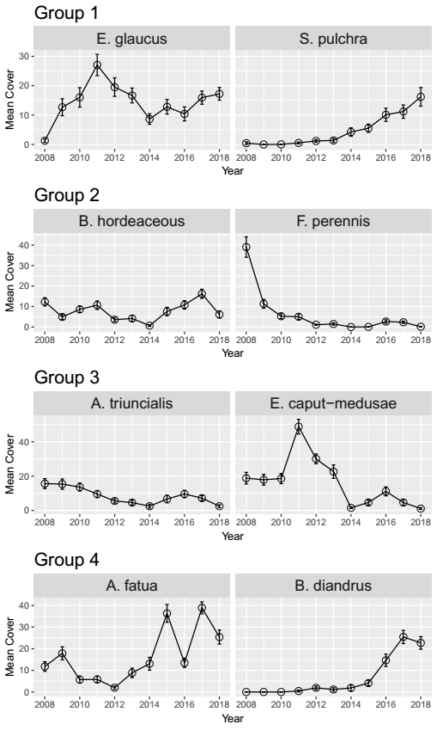
- Observations over time:
Old figure, showing assignments of individual plots over time
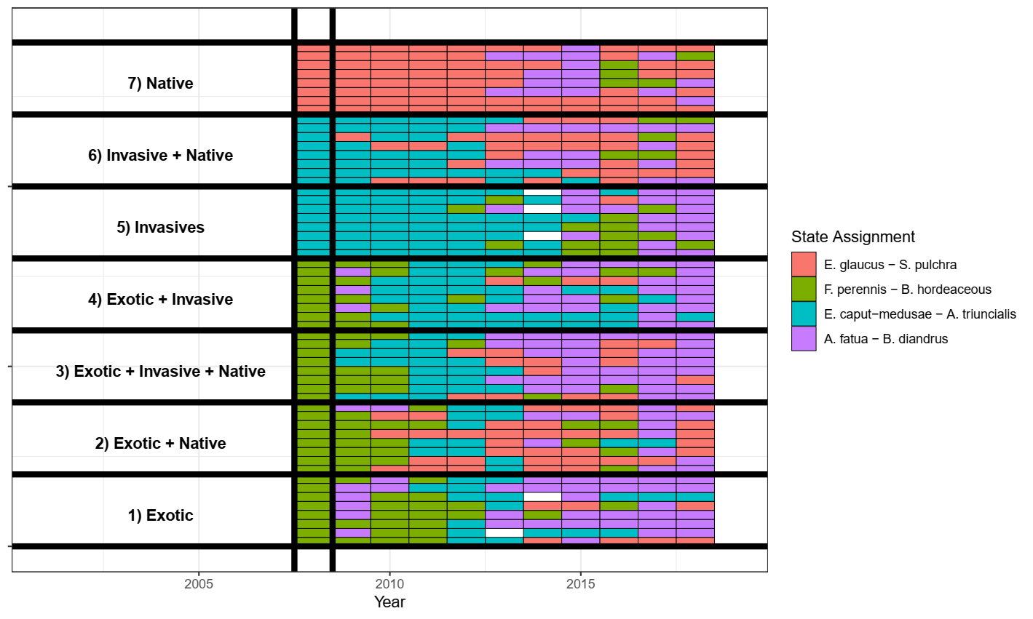

- MSM model output, estimated coefficients, visualized fits
- Can also include the coefficient table, etc.

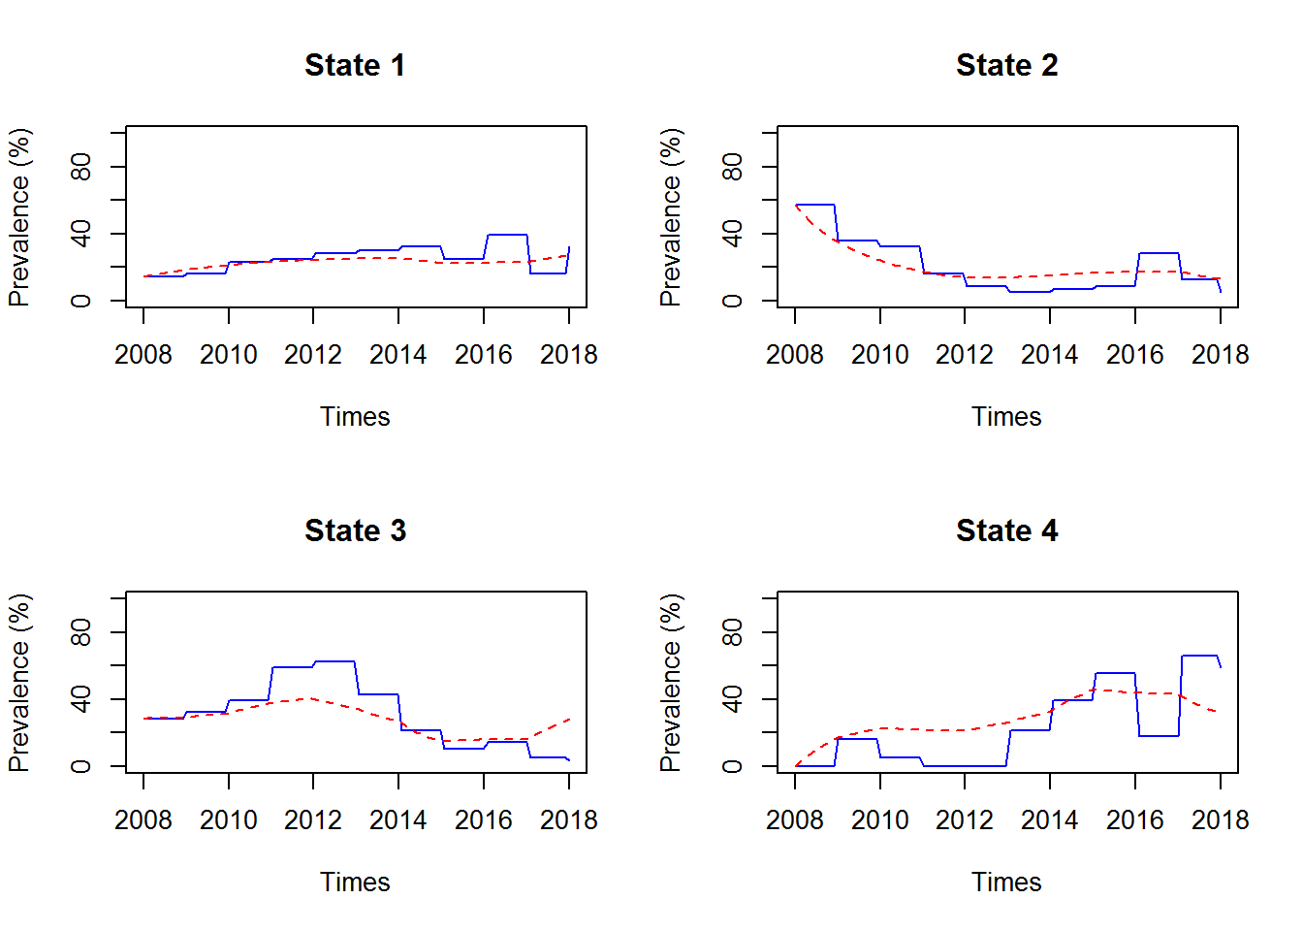

- All State Assignment Probabilities
